This Newsletter aims to provide information around safeguarding and Anti-Social
Behaviour (ASB), raise awareness of current issues across the district, promote the good work of our partner agencies and celebrate the successes we have had.
We can be contacted online: Report antisocial behaviour | Hart District Council by phone: 01252 774430 or by e-mail: communitysafety@hart.gov.uk

It’s not just the Grinch that steals Christmas…
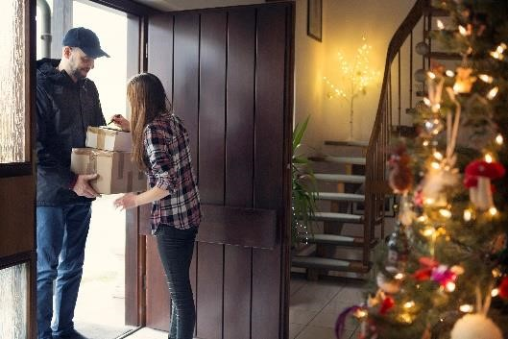
With the big day approaching and those last-minute gifts being delivered – we wanted to remind you again to be extra vigilant. We are seeing an increase in parcel thefts and want to ensure that we provide you with some further advice around protecting those deliveries:
- Always provide delivery instructions with online orders to ensure parcels are not left in sight.
- Keep an eye out for neighbours and take in parcels for them if you see them left in sight to keep them safe and return to them when they are home again.

For advice or help on your consumer rights around any parcels that you have not received and that may have been stolen, see the Consumer Council website.

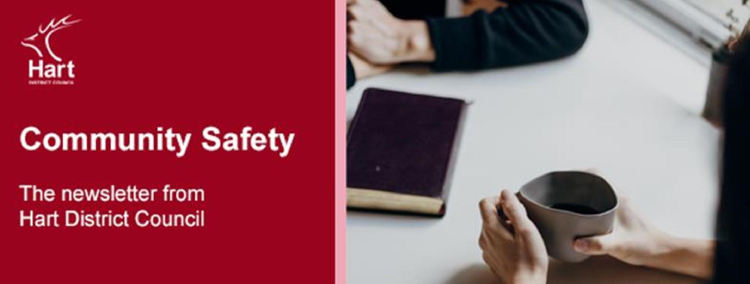


Stick with Wham! – Don’t get Scammed!

I
ssue
4
4

December
202
4

News of “gift card scams” has made the national news recently. With the festive season here, many people may be purchasing gift cards for loved ones. Please see below a breakdown of the frequent scams associated with gift cards:


Impersonation Fraud – This scam involves receiving a text/email/message from purported friends or family asking you to buy a gift card utilising an excuse of why they cannot do it themselves. Once you have purchased the card – they ask you to give them the details and steal the money. Ensure that you are certain who is asking you for details.

Draining Scams – This scam involves scammers entering stores and opening the sealed gift card, once open they take down the barcode number, then place the card back on the shelf. They then wait until you, the consumer, adds money to gift card and activates it. Once money has been added and the card activated at checkout, the scammer steals the money. When buying gift cards, ensure you check for any signs of tampering and if in doubt, ask a member of staff for assistance.

As always, despite best efforts and precautions, we cannot always prevent these scams from occurring. If you do become the victim of a scam – please report to Police and Hart Community Safety Team.
Christmas time – are you Home Alone?

Christmas for many is a time for family and friends and all things celebration – but for some, it’s a lonely time with no plans made.

There are a lot of events happening across the local area in the run up to Christmas so keep your eye on newsletters and local social media sites for events happening near you to get out and about and interact with others.
.
When the big day itself arrives, there’s no need to be alone this
Christmas time if you don’t want to be, there are several Christmas Lunches running in our wonderful Hart communities, so that those with no plans can find each other and spread some Christmas joy, please see the following links for details:

Fleet Town Council - Christmas Day Lunch 2024

Hartley Wintney Voluntary Care Group, Hook - Christmas Lunch

Christmas Lunch at Yateley Industries - Yateley Town Council

If you, or someone you know, needs any emotional, financial or mental health advice or support over the festive period, please reach out as appropriate to the Samaritans on 116 123 or the Mental Health Crisis team on 111.

The Hampshire and IOW Youth Commission launches their Big Conversation survey 2024!
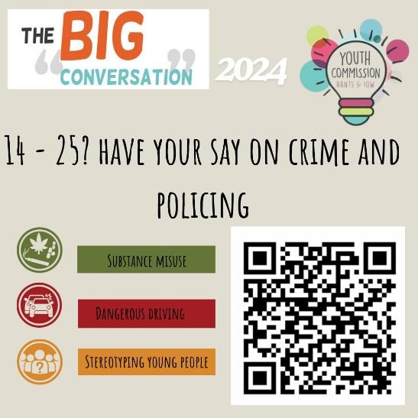
The Youth Commission is a diverse group of young people aged 14 to 25, from across Hampshire and the IOW, who are the voice of young people. They gather and represent the views of young people at a number of local and National strategic level meetings, attend events, create youth led campaigns and projects and help to shape Policing in the area.

Each year they hold The Big Conversation Survey and they present these recommendations to the Police and Crime Commissioner, Hampshire Constabulary and other partners, to support positive change for young people.

If you are aged 14 – 25, or are a parent, carer or someone who works with, or supports a young person in this age range, please do encourage your young people to give their views – please share this link and/or the QR code shown:

https://survey.alchemer.eu/s3/90712447/Youth-Commission-Big-Conversation-2024

Driving home for Christmas – make sure you see those faces!

Christmas is the time for celebration and many of us will be attending parties and may be tempted to drive ourselves back home after a Christmas tipple or two.

It is important to remember that each person is affected differently by alcohol and the risk is NEVER worth the cost. This means also ensuring not getting
into the vehicle of a drink driver either. Look out for each other and remain safe this festive season planning to use alternative means of transport to get yourself back home.

The Hart Community Safety team wish you all a safe, secure and Merry Christmas and a very Happy New Year!


If you have received this monthly Hart Community Safety Newsletter forwarded to you and you would like to subscribe and receive it directly, please drop us a line with your request at:
communitysafety@hart.gov.uk

