South Warnborough Parish Council
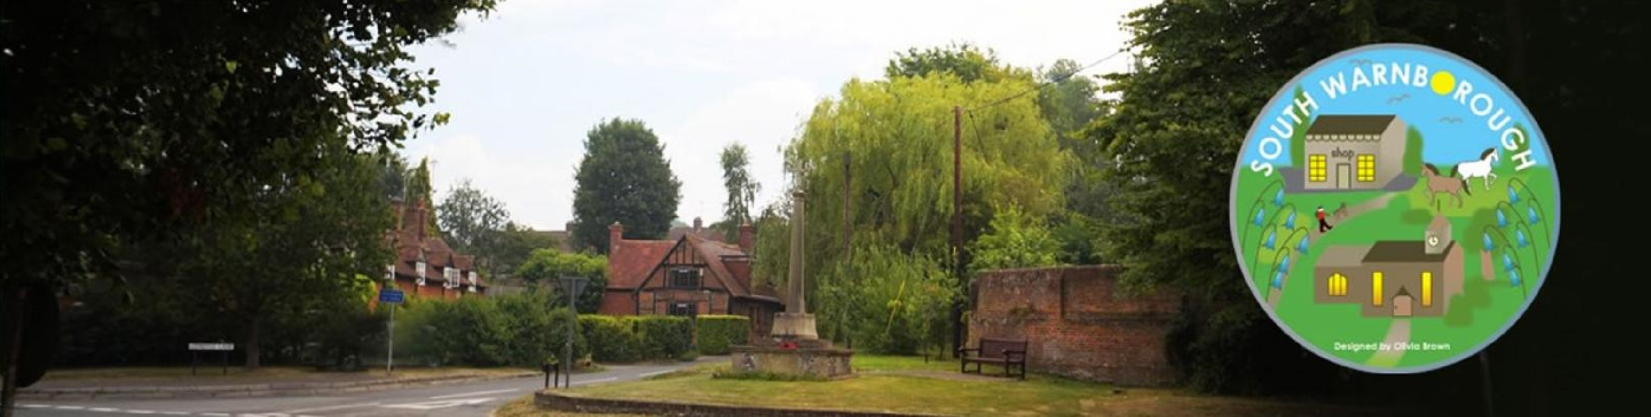
Traffic Management Working Group
27th March 2025

Agenda
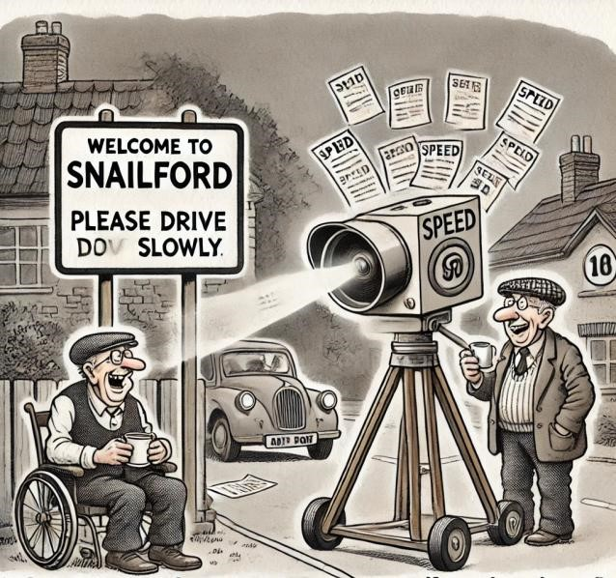
- The Journey so far
- Traffic calming scoping survey: results
- Traffic Management Proposal
- Q&A
At least we know where the precept is going
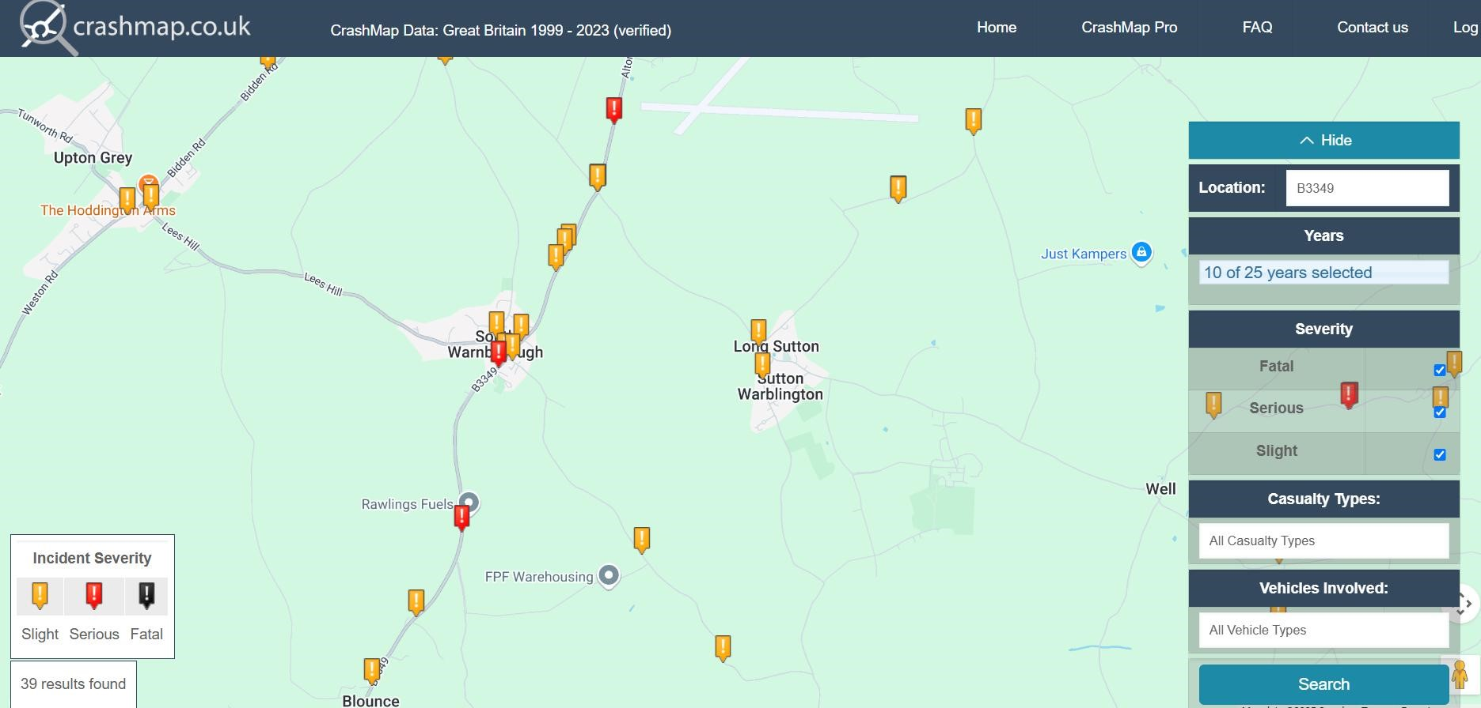
- Accidents for last 10 years, 2014
Crash map
– 2023
- 39 results

Traffic speed was the #1 issue identified in the 2022 survey
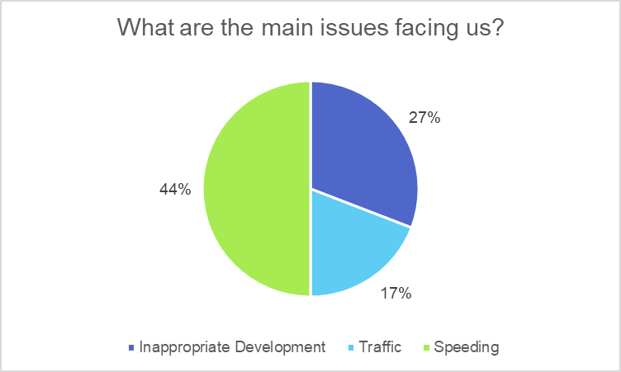

Since the 2022 survey several things have happened…
- 2nd Speed Indicator Device (SID) installed on the B3349, and a 3rd on Lees Hill, alerting drivers to their speed and reminding them to slow down
- Community Speedwatch (CSW) group operating regularly since May 2023, creating a visible reminder to drivers to slow down
- Although effective, is not sustainable for the long-term
- B3349 resurfaced [2024] - reducing noise but “encouraging” speeding?
- Improved speed limit lining implemented by HCC at the end of March 2025
o NOTE: A decision on the proposed Warehouse Development at Jct 5 on the M3 has been put on hold for now as the Warehouse Development at Jct 7 on the M3 has been approved
SID Data: 1 week, 1 direction
Day | Date | Vehicles 2025  (single direction) | Vehicles over 30mph % | Vehicles over 30mph Qty | Highest Speed
Monday | 17/3/25 | 3837 | 27.1% | 1040 | 55
Tuesday | 18/3/25 | 3949 | 25.9% | 1023 | 55
Wednesday | 19/3/25 | 3996 | 26.9% | 1075 | 70
Thursday | 20/3/25 | 4074 | 23.6% | 961 | 65
Friday | 21/3/25 | 3798 | 29.1% | 1105 | 60
Saturday | 22/3/25 | 3231 | 34.5% | 1115 | 60
Sunday | 23/3/25 | 2597 | 28.1% | 730 | 75

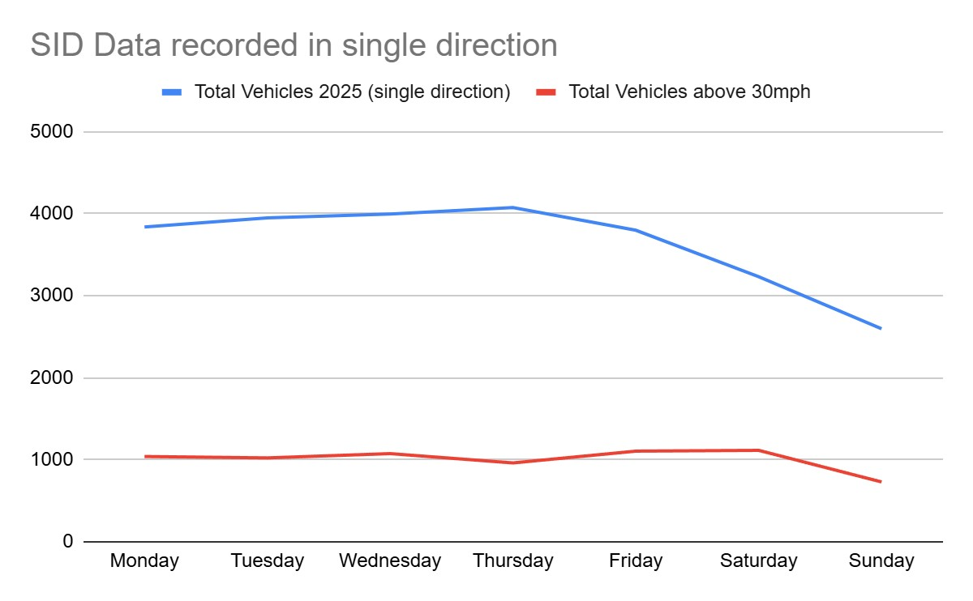

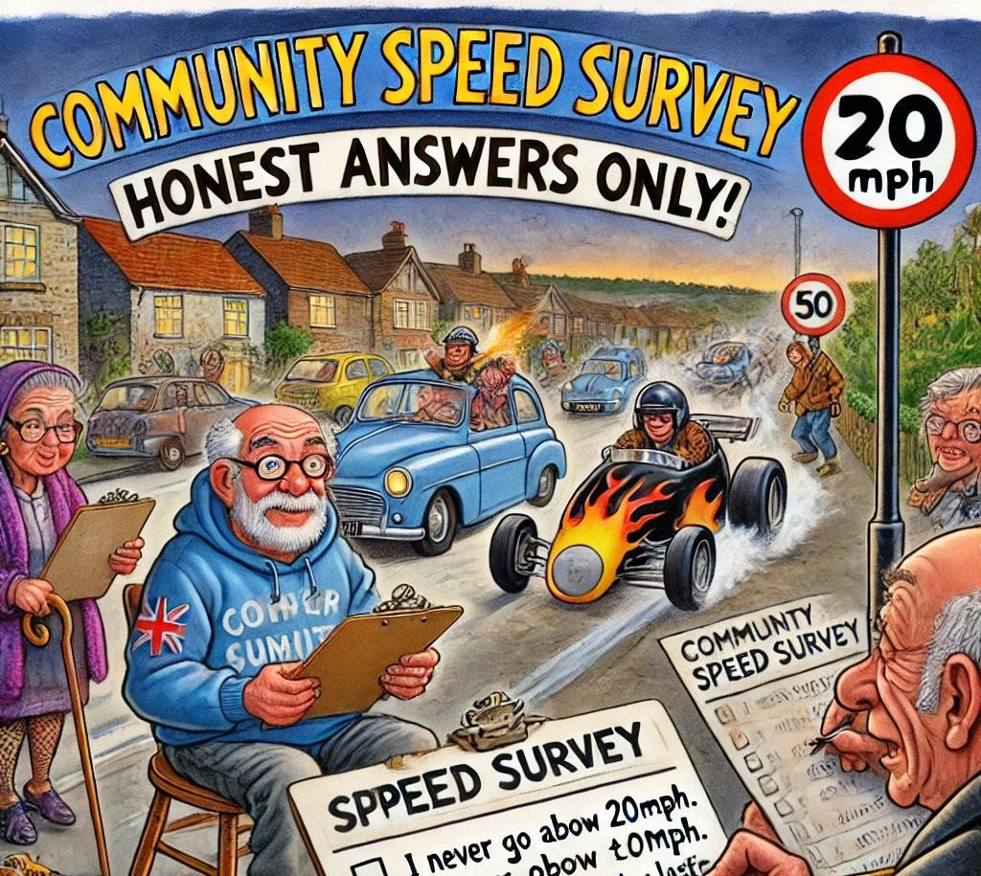
Traffic
calming
scoping survey
December 2024
SOUTH WARNBOROUGH PARISH COUNCIL

Traffic Calming Survey: December 2024
- Survey distributed via link / QR code & paper copies, on WhatsApp, posters, flyers, paper copies at village shop
○ Majority (98%) completed online
○ Left at village shop (2%)
- 117 responses received

Traffic
calming
scoping survey
–
results
SOUTH WARNBOROUGH PARISH COUNCIL
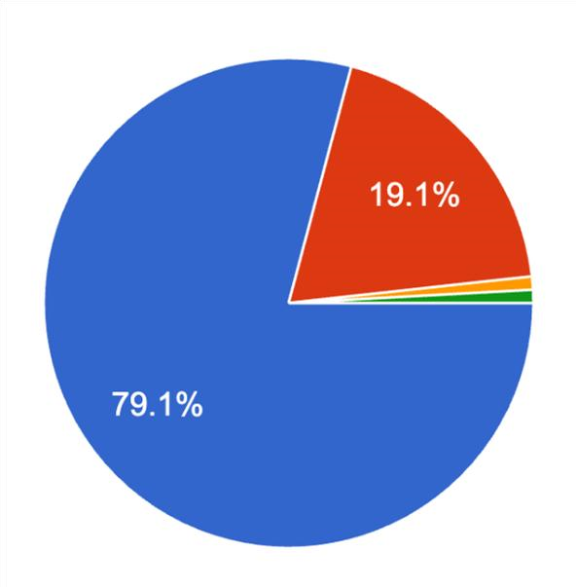
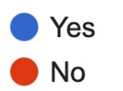
SPEEDING IS THE MAIN CONCERN OF FOUR IN FIVE VILLAGERS
Is speeding in South
Warnborough
your number one concern?
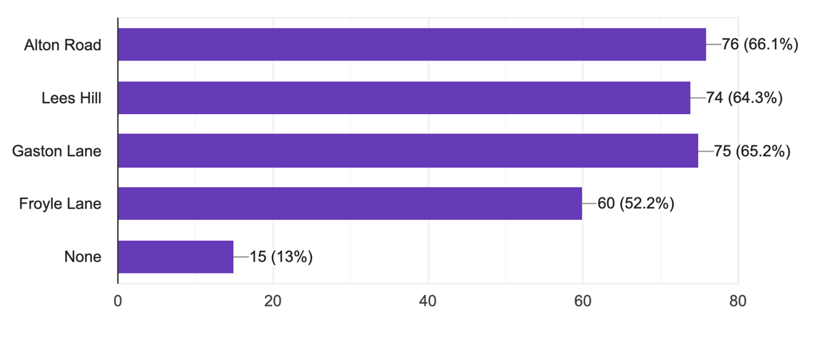
Would you be in favour of a 20mph speed limit on any of the following roads in the village?
THERE IS GENERAL AGREEMENT FOR A 20MPH LIMIT ACROSS THE VILLAGE
Are you in favour of the installation of raised speed tables on the Alton Road that include pedestrian crossings?

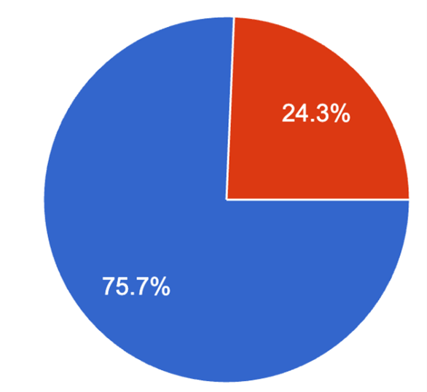
THE VILLAGE IS IN FAVOUR OF
RAISED TABLES WITH PEDESTRIAN
CROSSINGS
Traffic calming scoping survey – results for other options
Are you in favour of kerb build-outs or chicanes on the Alton Road
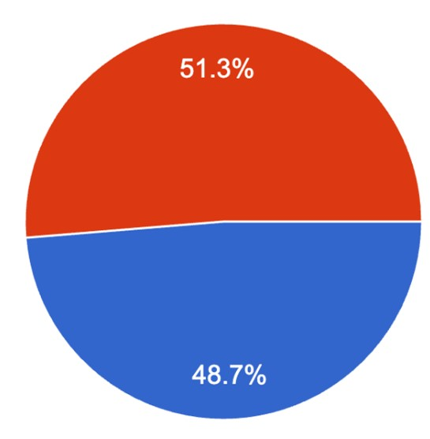

THE VILLAGE IS SPLIT
ON KERB BUILD-OUTS OR CHICANES
Are you in favour of the installation of a mini roundabout at the junction of Alton Road/Froyle Lane/Lees Hill?
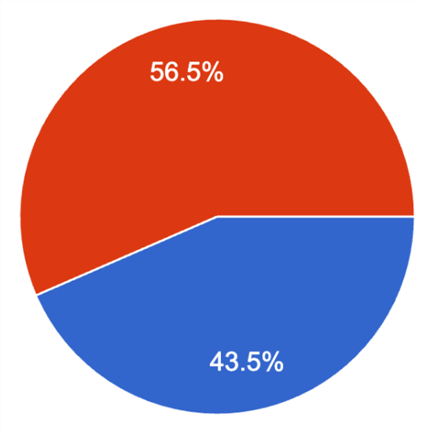 THE VILLAGE IS NOT IN FAVOUR OF A MINI
ROUNDABOUT
Expert advice tells us that the only longterm solution to speeding and unnecessary commercial traffic (HGVs) is physical traffic calming self-enforcing solutions, which force drivers to slow down, stop or seek an alternative route.
Concept for a 20mph Zone incorporating Traffic Calming
Measures (Road Humps) on Alton Road (B3349) in South Warnborough

Introduction
South Warnborough – a typical rural village in Hampshire. But…
- Main road is used as a through route to the M3 to the north, Alton and south coast to the south
- Quality of life is eroded by noise and air pollution from (at the last count) 7,000+ vehicles per day
- 47% of vehicles exceed the 30mph limit through the village
- Inappropriate vehicle speeds create a threatening environment for pedestrians and cyclists
- No defined crossing points for pedestrians
- Surveys of villagers in 2022 and 2024 identified traffic flow and noise as key concerns
- 2024 survey indicated 80% in favour of reducing traffic speed, 75% in favour of speed humps
Now is the opportunity to put things right
We can prevent the erosion of village quality of life before a crisis point is reached and give the village its identity back that it used to have many years ago
Now is the time for a 20mph Speed Zone and associated Traffic Calming Measures that provide a solution which is SELF-ENFORCING and would resolve the key issues
that will meet the needs of this community

Introduction
A 20mph Zone with Traffic Calming Measures would give the village
- Very effective improvement to road and pedestrian safety including people with a disability and cyclists • Dramatic reduction in traffic speed
- Environmental benefits of reduced noise and carbon emissions
Why do we need Traffic Calming Measures (Road Humps)?
- Hampshire Constabulary will not routinely enforce 20mph speed limits due to priorities and resources. No expectation on the police to provide any additional enforcement beyond routine activity
- A 20mph Zone to work must therefore rely on self-enforcing Traffic Calming Measures
- Studies show that speed humps are not noisy if vehicles are driven within the 20mph speed limit
- Speed “Bumps” are unacceptable and do not form any part of our proposal
- SIDs will remain important in ensuring compliance with the new speed limit
Informal Crossing Points
- Crossing Alton Road is a significant problem with virtually no pedestrian footways on the east side
- Two informal crossing points are proposed, to the north and south of Lees Hill crossroads

Background
Hampshire County Council Policy
- Following a policy change in 2024, all villages can now apply for 20mph Speed Zones ● Traffic calming measures a pre-requisite
- Not funded by HCC
South Warnborough Parish Council hopes to
- Reduce noise pollution
- Reduce traffic speeds
- Reduce number of HGVs
- Reduce number of vehicles rat-running through the village
- Increase safety for pedestrians and people with a disability

Background
Hampshire County Council approach
- Encourage wider use of 20mph Zone restrictions subject to
○ Suitability of location
○ Technical and legal assessment
○ Funding by the community
○ Introduction of Self-Enforcing Traffic Calming Measures
○ Local community support
- Police unlikely to object to evidence-led, self-enforcing speed limit proposals
- Drivers will see 20mph Zone as maximum speed not a target speed

Traffic Calming
Traffic Calming Measures make a 20mph Zone Self-Enforcing by slowing vehicles down to speeds at or below the 20mph speed limit
- Improve safety for vulnerable road users – cyclists, pedestrians both able and disabled
- Reduce pollution both noise and air
- Reduce vehicle emissions by altering volume, speed and composition of traffic flows and driving pattern
- Help to change the character of the road to fit the desired speed limit
National Guidance advises that 20mph Zones should include extensive Traffic Calming
Measures to make the 20mph Zone Self-
Enforcing
to achieve a greater level of compliance
Speed Humps as a Traffic Calming Measure
- Reduce vehicle speeds and traffic volume
- Reduce noise and pollution
- Improve road safety
- Discourage use of Alton Road as a cut-through – encourage drivers to find another route
- Can provide level crossing between footways – two proposed in the 20mph Zone

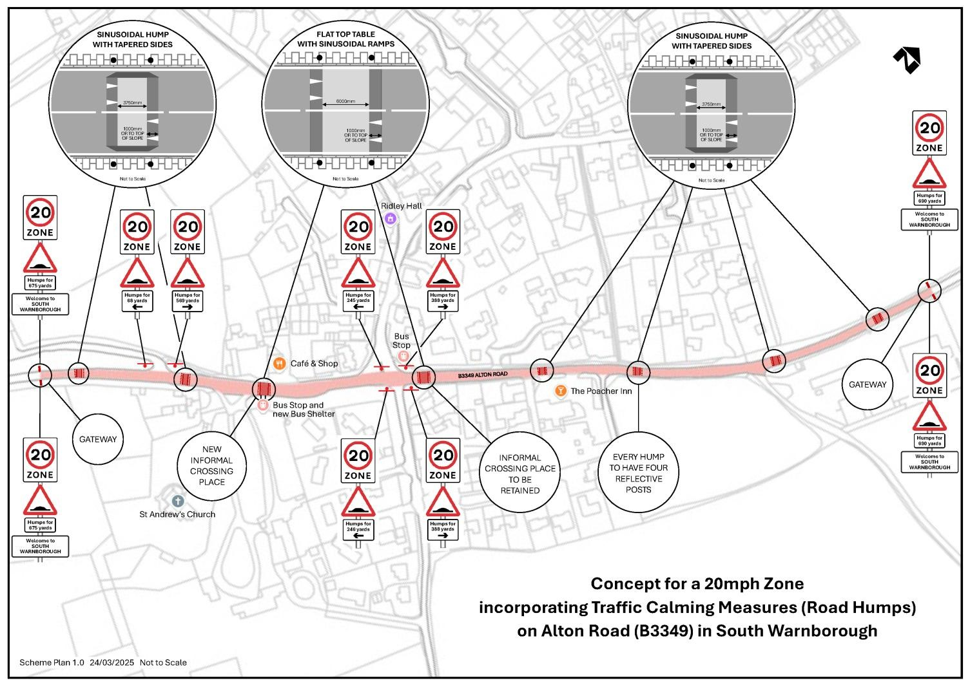

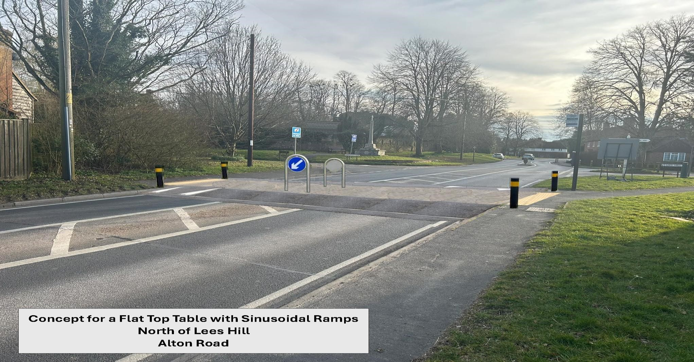
Informal Pedestrian Crossing Facility
Concept for a Flat
-
Top Table with Sinusoidal
Ramps
North of Lees Hill, Alton Road
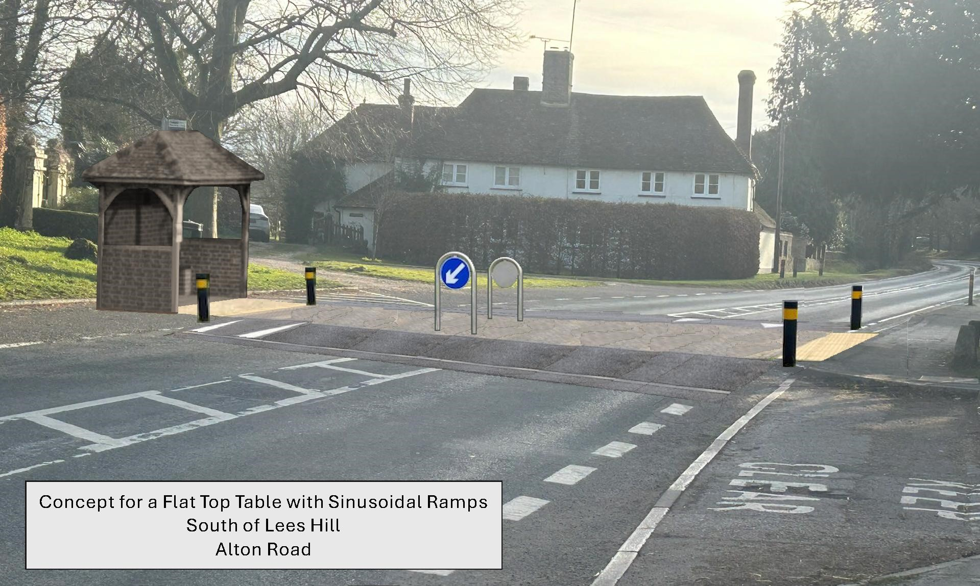
Informal Pedestrian Crossing Facility
Concept for a Flat
-
Top Table with Sinusoidal Ramps
South of Lees Hill, Alton Road
Why a 20mph Zone will Benefit You and Your

Community
A 20mph Zone with Traffic Calming Measures will result in
- Less traffic
- Less noise
- Less pollution
- Increased safety for pedestrians and others
Speed humps as a Traffic Calming Measure
- Self-Enforcing
- Reduce speeds by up to 20%
- Reduce traffic volume by 5% to 30% by deterring rat-running
- Very effective at protecting our most vulnerable road users – including children, people with disabilities, pedestrians and cyclists
- Significantly decrease the risk of being injured in a collision by up to 40%

20mph Zones reduce noise and air pollution
A slower speed limit can benefit the environment, our community and be safer for road users

Next steps
Community
buy
-
in
•
Scoping survey
•
Presentation of planned
proposal
(27
th
March 2025)
•
≥50% support
o
Regular updates to be provided by
SWPC
TC WG
throughout process
HCC
process
•
Application for 20mph zone + traffic calming (min. application
fee
, ~£175
)
•
Preliminary meeting with HCC
o
Confirmation of
responsibility
for maintenance (GO / NO GO decision by SWPC)
•
Outline proposal given to HCC
•
HCC’s own l
egal
, design, planning
processes
(
non
-
refundable
costs to be borne by SWPC)
Funding
raising
•
GO / NO
GO
decision by
SWPC / community; if GO full fund raising anticipated:
o
Community
o
Private
o
Public e.g. CFI, PWLF
Project
t
imeline
•
HCC Consultation
process
es including SW
•
Implementation 1
–
2
years ?

